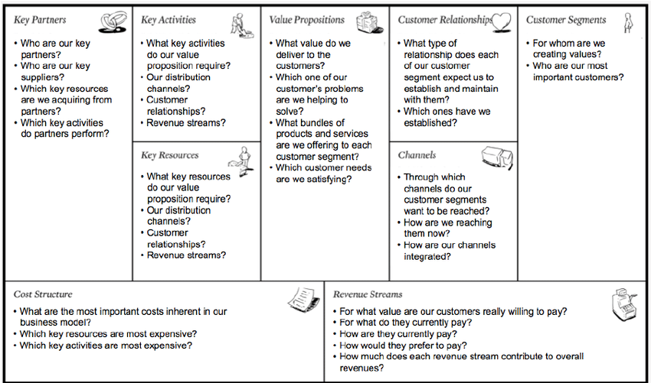

# Entry tasks & questions (before seminar)

Prepare answers to task 1 below. During the seminar, you will orally present your findings in regards to task 1 to your fellow classmates in smaller groups.

Read through task 3, in preparation for working with this task at the seminar.

# Task 1: Business Model Canvas Mapping

Identify and choose one company that uses an OSS project as part of, or enabler to, their product, service or operation (for examples, visit TODO Group1 and OSS Captial2). The OSS can be either of Community and Commercial open source, considering the definitions by Riehle (2009).

Identify and study relevant resources available on the internet (e.g., company website, news and media articles, OSS community resources). Use the BMC (Osterwalder’s Business Model Canvas) and map its nine components on the selected company, and thus describe the company’s business model. For example:

What is the company’s value proposition?

Who are the customers?How is the value proposition delivered and supported to the customers?

What revenue streams are there?

What are the key resources, activities, and partners?

What costs are there?

**1 Key partners**:

* Content Owners, to acquire licenses
* Internet service providers, in order to deliver the content in real time aka streaming
* Amazon web services, they host most of netflix
* Directors, actors, writers and their guilds/unions, they can play a huge part in the content available
* Prizes and film festivals, can help spread the word, especially if a netflix title runs
* Investors, a lot of the content is funded by external money, despite having a lot of users they still need the investors

**2 Key Activities:**

* Technology and development, despite the focus on content, netflix is a tech company. Their Open connect standard that defines the interfaces and protocols, its pre-positioning of content locally outside of peak traffic.
* Content licensing and acquisition, adding content
* Content creation
* Marketing
* Influencing
* Analytics

**3 Key resources/Assets:**

* Brand
* App/Website
* Content
* Algorithms, for analysis of data and improvement of the business, app, features, etc
* Tech staff, from DVD mailing to streaming
* Actors, writers, filmmakers
* Studios

**4 Value Proposition:**

* Content library
* No ads
* On demand consumption (sometimes)
* Binge watch-ability
* Simple pricing
* Convenience and mobility
* High quality connection
* There is no “premium” content
* Personalisation
* Localisation

**5 Customer Segments:**

* Anyone wanting to watching something, from any age, regularly

**6 Channels:**

Netflix itself is a channel for content distribution

* Any digital device with a screen and internet
* App stores
* Help and support channels
* Social media
* Media outlets
* Film festivals

**7 Customer Relationships:**

* Self-service though app and website
* User support
* Ability to watch content on demand
* The recommendation system

**8 Revenue:**

* Subscription fees, international streaming, 3 different plans depending on needs
* () Licensing revenues for netflix owned content

**9 Cost Structure:**

* Tech and development
* Marketing
* Administration
* Cost of revenue
  + Content amortisation (Biggest cost)
  + Payment processing fees
  + Customer service
  + Streaming delivery costs
  + Operations costs

Consider how the OSS project and its community fits into the company’s business model. For example, which of the nine BMC components do they relate to?

**OSS:**

Key activities, mostly, but all of them are related to oss in some way.

Most of their oss goes into the following:

* Big Data, Tools and services to get the most out of (big) data
* Build and Delivery Tools, Taking code from desktop to the cloud
* Common Runtime Services & Libraries, Runtime containers, libraries and services that power microservices
* Content Encoding, Automated scalable multimedia ingest and encoding
* Data Persistence, Storing and serving data in the cloud
* Insight, Reliability and Performance, Providing actionable insight at massive scale
* Security, Defending at scale
* User interface, Libraries to help you build rich client applications

# Task 2: OSS Licenses

For the OSS project that you selected in task 1:

Identify what kind of OSS licenses that are used. Per Lindman et. al (2011), classify the licenses you have identified as permissive or restrictive.

What implications and conditions do these licences have on the participants and their respective business models?

How does the OSS licencing affect the relationships between the platform leader/governing body of the SECO/community and its participants?

# Task 3: Software Ecosystem Analysis

Return to the company and OSS community identified in task 1, and consider the community as aSECO and the OSS project as the software platform underpinning the SECO. Review and answer the following questions, based on the papers by Jansen & Cusumano (2013) and Riehle (2009).

What role does the company have in the SECO/community according to the definitions provided by Jansen & Cusumano (2013), i.e., platform leader, niche player, bridge player? How can this be noticed in the company’s business model?

Exemplify other participants in the SECO/community. What roles do they have? How do their use of the platform/OSS project differ from that of the company that you first identified?

Can the SECO/community be classified as a commercial or a community open source? Seedefinitions by Riehle (2009).

What does SECO/community governance look like? See definition by Jansen & Cusumano(2013). How can participants in the SECO/community affect the development of theplatform/OSS project

# Project assignment: Next steps

(For grades 4&5) Consider how you can integrate and use a software ecosystem in your business model, and if and how you potentially could benefit from this. See project task 8.

Initiate prototyping of your solution, see project assignment task 5, with the aim of

concretizing your solution idea, internally within group

for grade 5, assessing your product-market fit by using a very simple prototype (paper or mockup) with potential customers or users